Year 13 Geography 2022

QUEENSTOWN WINTER FESTIVAL
AS91428

To analyse a significant contemporary event from a geographic perspective. The Queenstown Winter Festival in 2019 is the focus and briefly include the 2020-2022 winter festivals.
Resources are also included in this handout. This handout is available online through Teams files
NAME:

The marking schedule is included in this handout.

MARKING SCHEDULE AS91428 Level 3 Credit: 3 UE Reading

Name:________________________________________ Date;_______________________

Evidence for Achievement | Evidence for Achievement with Merit | Evidence for Achievement with Excellence
The student analyses a significant contemporary event from a geographic perspective. This means that the student: | The student analyses, in depth, a significant contemporary event from a geographic perspective. This means that the student: | The student analyses comprehensively a significant contemporary event from a geographic perspective. This means that the student:
TASK 1  Outlines the nature of the event from a geographic perspective, such as the spatial nature of the event, interaction between people and the environment, and characteristics of the natural and/or cultural features that make up the event. | TASK 1  Marked as ‘Achieved’ only | TASK 1  Marked as ‘Achieved’ only
TASK 2  explains the planning and decision-making process | TASK 2  explains in detail the planning and decision-making involved in the event | TASK 2  explains in detail and evaluates the planning and decision making involved in the event. The evaluation must indicate the effectiveness of the components of the planning and decision-making. This may, for example, include how people’s values, perceptions, and perspectives influenced decision-making processes

TASK 3  Identifies and explains the social, economic and/or environmental impacts of this event  AND uses geographic terminology and concepts  AND supports their analysis with relevant evidence. This may include visual material such as diagrams, graphs, tables, and other appropriate visual media. | TASK 3  Explains in detail the social, economic and/or environmental impacts of the event. These could include both positive and negative impacts  AND uses appropriate geographic terminology and concepts  AND supports their in-depth analysis with relevant detailed evidence that may include visual material such as diagrams, graphs, tables, and other appropriate visual media. | TASK 3  Explains in detail and evaluates the social, economic, and/or environmental impacts of the event. This could include a discussion of both positive and/or negative impacts. The evaluation should include a judgement as to the significance of the impact, or comparison of the level of impact the event has on the different aspects  AND consistently uses appropriate geographic terminology and concepts throughout their analysis  AND supports their analysis and evaluation with a range of relevant detailed evidence that may include diagrams, graphs, tables, and other appropriate visual media. Their significance is explained and shows insight  Concepts may include how people’s values, perceptions, and perspectives influence decision-making processes. The student shows an understanding of the concept that there is an interaction of all anticipated impacts of the event and that this is a fundamental part of planning and decision-making.

Final grades will be decided using professional judgement based on a holistic examination of the evidence provided against the criteria in the Achievement Standard.

A= 3A or 2A, 1M
M=1A. 2M or 1A, 1M, 1E
E= 1A, 2E
NA= any 2 at A, M, E

NCEA AUTHENTICITY STATEMENT
SUBJECT AREA: Geography
NCEA LEVEL: Three
ASSESSMENT NUMBER: Achievement Standard: 91428
VERSION: 2
ASSESSMENT TITLE: Analyse a significant contemporary event from a geographic perspective
CREDITS: 3 University Entrance Literacy Reading Credits

Date Assigned: DUE DATE:

AUTHENTICITY STATEMENT:
This statement confirms that the work you have handed in is your own. Any instances of plagiarism will result in an instant Not Achieved grade being entered for this Achievement Standard.

I _____________________________________________________________________ attest that the work I have submitted for this assessment is my own. I accept that if my work contains any instances of plagiarism, I will gain a Not Achieved grade for this Achievement Standard.

Signed: _________________________________________________

Date: _______________________

Overall grade for this Achievement Standard: ______________________________________

Task 1.

Task 2.

Task 3:

VERIFICATION STATEMENT:
This statement confirms that you accept the grade that your teacher has given you for this assessment. If you wish to challenge this grade, your work will be passed on to the Head oF Learning Area as well as the Principals Nominee for further consideration.

I ____________________________________________________________________ accept that the above grade is accurate for this assessment

Signed: _________________________________________________

Date: _______________________

AS 91428 Queenstown Winter Festival

Assessment Task

Geographic perspective refers to a spatial dimension and interaction between people and the environment.

Introduction:
This assessment requires you to analyse the planning, decision making and impacts of a significant contemporary event in Queenstown. For the purpose of this assessment we will be studying the Queenstown Winter Festival (last held in 2019), a large event with many different activities occurring throughout the Festival week. The Queenstown Winter Festival is the Southern Hemisphere’s biggest winter celebration. This event was cancelled in 2020 and 2021 due to the Covid-19 pandemic so students are requested to research the 2019 event. This has been approved by NZQA Geography. This year, there has been a smaller event ‘Welcome to Winter’ which you can briefly write about as a temporal pattern of change.

Achievement | Achievement with Merit | Achievement with Excellence
Analyse aspects of a contemporary geographic issue. | Analyse, in depth, aspects of a contemporary geographic issue. | Analyse comprehensively aspects of a contemporary geographic issue.

Task 1: Outline the nature of a significant contemporary event
(MARKED AS ACHIEVED ONLY)

To do this you will need to read the selection of resources in this booklet (plus any others you find that are relevant) and make notes on the following:
- The purpose and significance of the event
- The location of the event and the significance of the location
- Specific features of the event
- Groups affected by the event
This task will involve outlining the nature of the event and annotating a map to show the spatial dimension significance of the environment to the event. You will present this on a A3 poster format.

Task 2: Explain and evaluate the planning and decision making involved in the event (MARKED AS ACHIEVED, MERIT, EXCELLENCE)

- Explain in detail the planning and decision-making (P and DM) that was carried out and required for the Queenstown Winter Festival.
You could refer to:
- P and DM needed to make the event successful – before, during and after the event
- P and DM people involved – individuals, communities, officials and official bodies
- P and DM – permissions, consents and permits required for the event.
The depth of evidence expected for the planning and decision-making aspect. Make sure you include:
- Decisions to meet legislative requirements such as consents, permits and licences needs to include what is involved by the organisers to secure these.
- If permits significant to this event are needed, like for stage construction, fireworks, extended opening times, they should be included when examining the planning.
- Further event planning details regarding the consent process, eg. How sponsors and entertainers were secured.
Look at the ‘Event Toolkit’ that is in the Resource section of this handout.
- Evaluate the planning and decision-making that took place for the Queenstown 2019 Winter Festival.
You could refer to things like:
- How successful/unsuccessful the planning and decision-making was
– What parts worked well and any parts that did not work so well?
– Ranking the importance of different things that were done
- Changes to the planning and decision-making (if any) for the next years Queenstown Winter Festival event and others in the future (refer to the cancellation of 2020 and 2021 festivals due to Covid-19 but do not write in depth).
- Judgement of which parts of the planning and decision-making were the most important/essential, and why.
Remember to incorporate:
- Geographic terminology
- Geographic Concepts
- A range of detailed, relevant evidence (specific examples)
- Include diagrams, graphs, tables and other appropriate visual media

Task 3: The social, economic and environmental impacts
ENVIRONMENTAL
The possible adverse effects of the environment resulting from an event.

ECONOMIC
Economic impact of events can be defined as the net change in an economy resulting from an event. Can be both regional and national.

SOCIAL
The effect of an event on
the social fabric of the community and well-being of the individuals and groups
families.

- Explain in detail the social, economic and/or environmental impacts of the Queenstown Winter Festival.
This may include:
- Positive / negative impacts and
- short-term/long-term impacts.

- Evaluate the impacts of the Queenstown Winter Festival.
- Do this by making an assessment or judgement of the significance of the various impacts
(ie. which impacts do you think were most important?)

Remember to incorporate:
- Geographic terminology
- Geographic Concepts
- A range of detailed, relevant evidence (specific examples)
- Include diagrams, graphs, tables and other appropriate visual media

RESOURCES
(all accurate as at 19 May 2022)
You can also source additional information of your own
http://www.winterfestival.co.nz/

https://www.facebook.com/QueenstownWinterFestival

https://en.wikipedia.org/wiki/Queenstown_Winter_Festival

2019 Queenstown Winter Festival (QWF) programme:
https://www.winterfestival.co.nz/programme

2019 QWF report: https://static1.squarespace.com/static/5ba4424bd86cc936f48583fb/t/5d43765308f62b0001053e93/1564702306200/FOR+WEB.pdf

Article on the 40 years of QWF
https://www.queenstownnz.co.nz/stories/post/forty-years-of-queenstown-winter-festival/

https://www.rnz.co.nz/news/national/247703/queenstown-winter-festival-turns-40

Articles promoting the 2019 QWF
https://www.realjourneys.co.nz/en/blog/queenstown-winter-festival-2019/

https://www.scoop.co.nz/stories/AK1904/S00395/queenstown-winter-festival-programme-release.htm

https://www.queenstownnz.co.nz/plan/getting-here-and-getting-around/

Articles written during the 2019 QWF
https://www.odt.co.nz/news/the-south-today/thousands-turn-out-winter-festival

Article on the preparation for the 2020 Winter Festival
https://media.newzealand.com/en/events/queenstown-winter-festival-already-gearing-up-for/

Article written on the 2010 QWF
https://experiencequeenstown.com/news/winter-festival-has-huge-impact-on-queenstown-visitor-numbers-and-economy/

Queenstown Lakes District Council
http://www.qldc.govt.nz/

Ngai Tahu Tourism
https://www.ngaitahutourism.co.nz/

Articles written on previous QWF events
https://info.scoop.co.nz/American_Express_Queenstown_Winter_Festival

Social implications of QWF
http://www.nzherald.co.nz/nz/news/article.cfm?c_id=1&objectid=10656559

http://books.google.co.nz/books?id=LonbAAAAQBAJ&pg=PA77&lpg=PA77&dq=queenstown+winter+festival+social+issues&source=bl&ots=yWz183yGff&sig=RFftPwNs-ann8vKAzfKcwsJyCzw&hl=en&sa=X&ei=Bxh8VLf0E4n98QXk7oLIAw&ved=0CEIQ6AEwBzgK#v=onepage&q=queenstown%20winter%20festival%20social%20issues&f=false

Drug use in Queenstown
https://www.stuff.co.nz/national/112352168/meth-nzs-top-drug--its-in-the-water

You Tube

https://www.youtube.com/watch?v=U_sx70H2CO0 Real Journeys QWF 2019 Programme
https://www.youtube.com/watch?v=sEve3se1e_U Real Journeys QWF 2019 After movie

https://www.youtube.com/watch?v=C_0livqdJME Queenstown Winter Festival Highlights 2017

https://www.youtube.com/watch?v=daY9brQQZ08 QUEENSTOWN WINTER FESTIVAL! | Well Groomed Episode 04

https://www.youtube.com/watch?v=FczLH1u-O78 Info-tainment - 2018 Queenstown Winter Fes

TASK 1 – TEMPLATE TO COMPLETE TO ASSIST IN YOUR ASSESSMENT WRITING

What is the purpose and significance of the Queenstown Winter Festival?

Where is the QWF within Queenstown?

What is the significance of the location?

What are specific features of the QWF?

What groups are affected by the QWF?

Task 1: QWF Programme for 2019

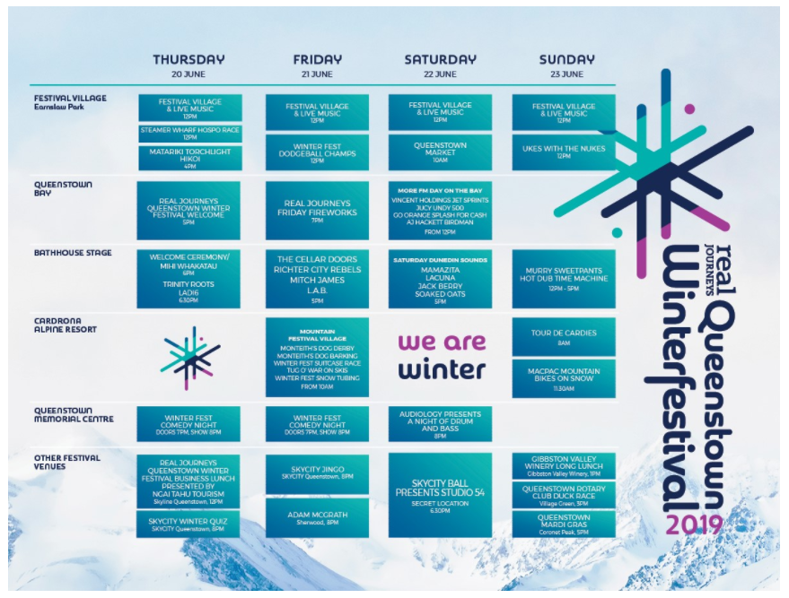

Task 1: Outline map of Queenstown
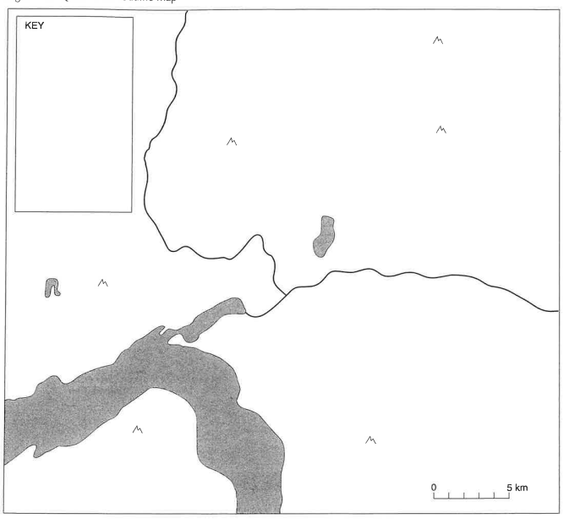

Task 1: Tourist map of Queenstown
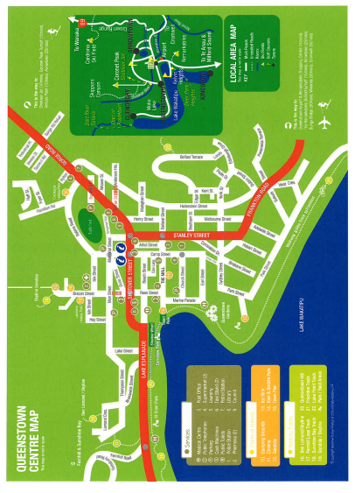
TASK 2 - TEMPLATE TO COMPLETE TO ASSIST IN YOUR ASSESSMENT WRITING

There was quite a lot of planning involved in carrying out the Queenstown Winter Festival (QWF). To make the event successful, planning occurred before, during and after the event. Refer to the Event Checklist.

BEFORE
How are sponsors decided?

How are entertainers secured?

How many people (individuals / groups / community / officials) are involved in organising the QWF?

How many consents were needed to hold the QWF?

Permits were needed for Stage construction, Fireworks, Extended opening times, and what else?

DURING

What went well with the 2019 QWF?

What did not go well with the 2019 QWF?

What could be done better with the 2019 QWF?

AFTER

2019 QWF Report available from https://static1.squarespace.com/static/5ba4424bd86cc936f48583fb/t/5d43765308f62b0001053e93/1564702306200/FOR+WEB.pdf

Is there anything else we should know about?

Here is an example of ‘Event Management Planning’

What type of resources are required in event management?
- Money
- People – both paid and volunteers
- Machinery
- Infrastructure
Leadership
Key characteristics:
- Good interpersonal skills
- Good informational skills
- Knowledge of decision making strategies
- Ability to keep the vision alive
Event planning components
- Seeing the want/need - setting goals and objectives
- Forming an organising committee
- Allocating committee responsibilities
- Deciding on dates and plan a time-line
- Budgeting – grants/sponsorship/fundraising
- Location/venue
- Risk management, security plan, traffic management
- Essential services, contractors, food vendors
- Cleaning & maintenance
- Waste management
- Marketing and promotion
- Invitations/ticketing
- On the day
- After the event
- Post event evaluation

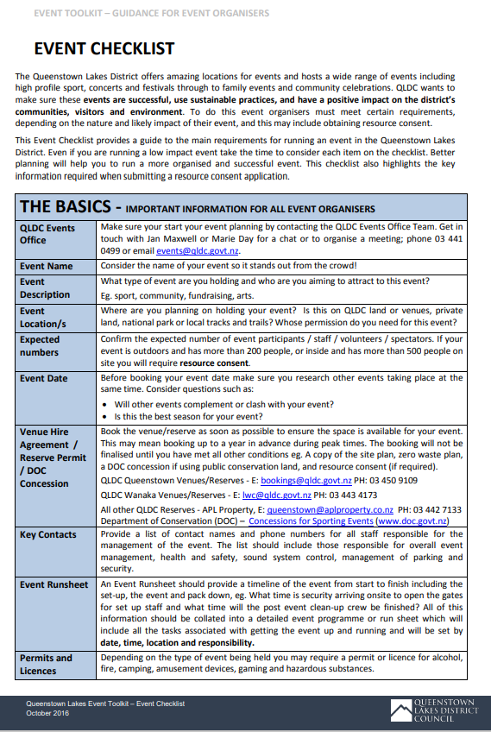

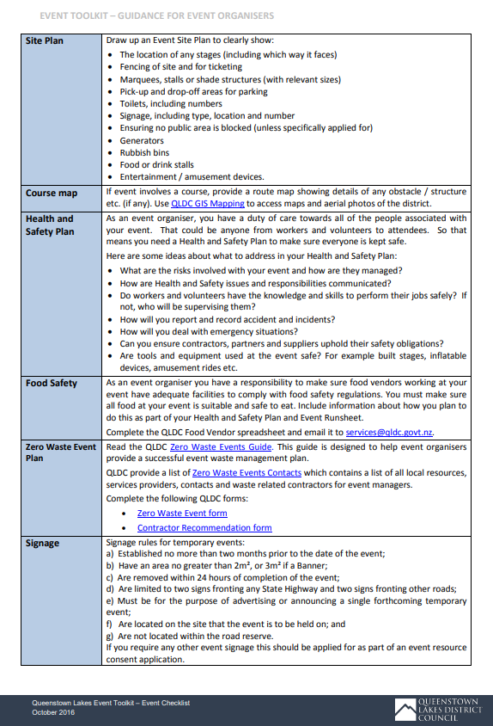

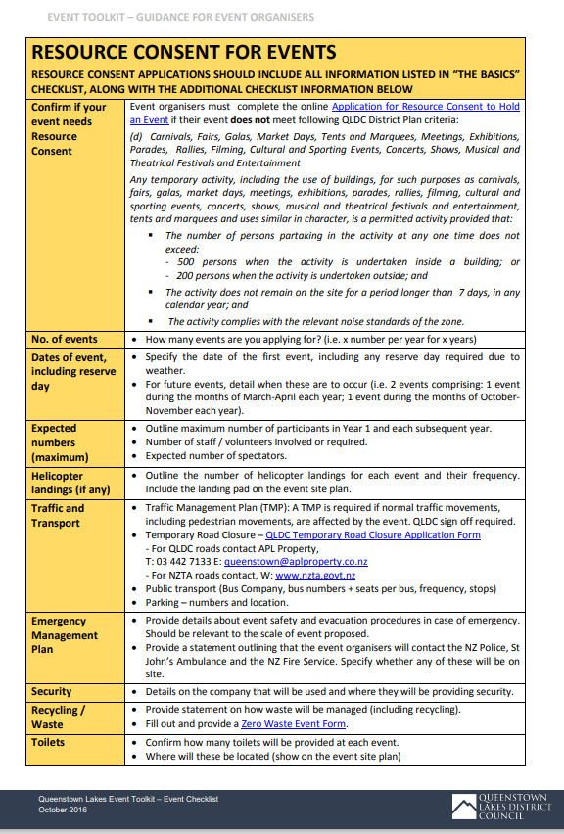
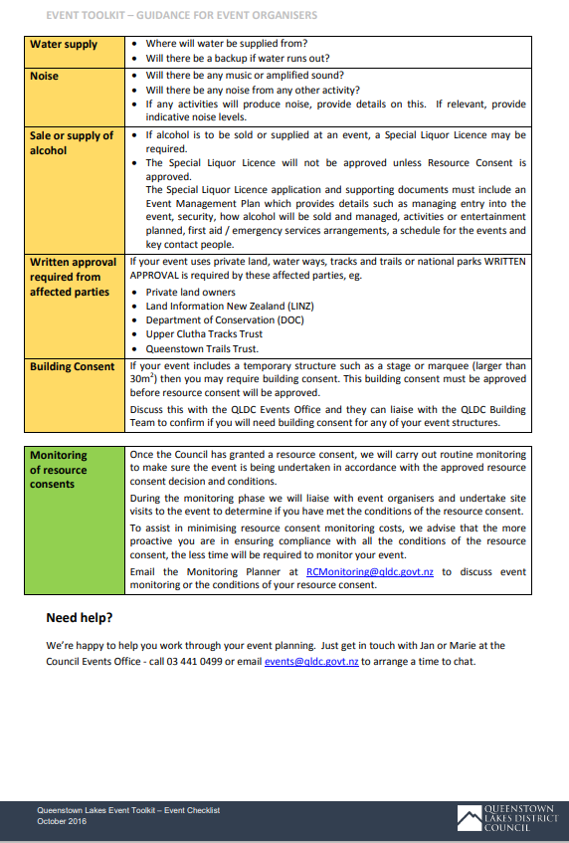

TASK 3 – TEMPLATE TO COMPLETE TO ASSIST IN YOUR ASSESSMENT WRITING

Social Impacts/Changes | Economic Impacts / Changes | Environmental Impacts / Changes
Positive –Short Term | Positive –Short Term | Positive –Short Term
Positive – Long Term | Positive – Long Term | Positive – Long Term
Negative – Short Term | Negative – Short Term | Negative – Short Term
Negative – Long Term | Negative – Long Term | Negative – Long Term

Which impacts were most important?

Why? I think that… is the most significant impact from the event. This is because…..

